**WILSON LAKE NEWSLETTER**

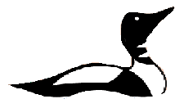

Wilson Lake Association

**Fall 2022**

*“Do unto those downstream as you would have those upstream do unto you.”* ~Wendell Berry

**Join us at…**

Website: <http://wilsonlake.net/> Facebook: *Wilson Lake Association*

Email: [Wilsonlakeas@gmail.com](mailto:Wilsonlakeas@gmail.com)

**Board Members 2022**

Isobel Michaud- *President*

Eric D. Cook- *Vice President*

Ann Marie Nadeau- *Treasurer*

John Nadeau- *Erosion Control*

Lisa Flayhan- *Secretary*

Wayne and Sharyn Reetz- *Plant Patrollers*

Rich Chevalier- *Water Quality*

Jeff Brown- *Board Member*

Diane Hansen- *Board Member*

Teg Rood- *Board Member*

David & Diana Spahn- *Plant Patrollers*

Margaret Sitarz- *Board Member*

Bob Anderson- *Boat Safety*

***-------------------------------------------------------------------------------------------------The 2022 Watershed Survey is Complete!!!***

**Letter from the Lakeside**

With the help of many volunteers, AWWA, and Maine DEP, we conducted our full-scale decadal watershed survey on April 30th. Special thanks to all our volunteers and to the Lake Stewards of Maine for awarding us with a $500 grant to help fund the project. Full results from the survey can be found at our website at [2022 Wilson Lake Watershed Survey Report](http://wilsonlake.net/wp-content/uploads/2022/10/Wilson-Lake-Watershed-Survey-2022_compress.pdf). For comparison, you can also view our [2010 Wilson Lake Watershed Survey Report](http://wilsonlake.net/wp-content/uploads/2019/06/Wilson-Lake-Watershed-Survey-Report-2.12.10.pdf) or visit our website for more info.

The watershed survey exemplifies everything we represent at WLA: volunteers driven by a long-term mission to protect Wilson Lake.

**This year’s survey happens only every 10+years and provides a “snapshot” of our lake and what we can do to help improve water quality.** From the survey, we identified 68 erosion sites that were directly impacting Wilson Lake. Of these, 10 were high impact to the lake, 54 were medium impact, and 4 were deemed low impact

Attached to this newsletter is a letter detailing the results of the watershed survey for your property.Starting this year, we will be using the survey to help address run-off problems.

If you would like help in reducing runoff on your property, please read the watershed report recommendations and reach out to us for help!

**As the report confirms, the challenges remain: Run-off/Erosion. Algae blooms. Invasive plants.** More use of Wilson requires greater participation. With over 200 camps on the lake, we have at least 1000 people that enjoy Wilson every year—and we can all do our part.

An easy action to help protect our lake is to read over the survey results and help address any erosion spots highlighted in the survey.

Another easy way to participate is to [purchase WLA gear](https://www.bonfire.com/wilson-lake-classic-design/) (see last page!), attend our

Annual Meeting, and keep an eye out for unusual plants and report them to us at WLA!

**~Isobel Michaud**

**Watershed Survey 2022**

About 15 people from Wilson Lake, the WLA, interested parties, AWWA and Maine DEP conducted our decadal watershed survey for our lake on Saturday, April 30.

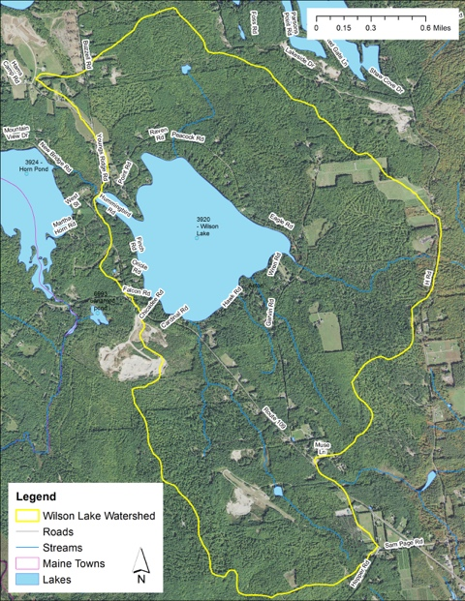

To understand what a “watershed” is, picture a big bowl with Wilson at the bottom. Any water that enters the bowl drains or “sheds” into the lake. Snowmelt and rain and streams drain down into the lake from the area outlined in yellow.

This is Wilson’s watershed: a four-square mile area that includes all the camp roads, a chunk of Route 109, and other area set back a bit from the lake. Wilson Lake is about 308 acres (~0.5miles2) which means an area **8 times as large as the lake affects water quality.**

The purpose of the survey was to get eyes on as much of this watershed as possible to identify any areas of runoff.

Runoff is the water that flows across the watershed and into the lake and **is one of the biggest threats to our lake along with invasive plants.**

With that runoff comes all the pollutants that cause algae blooms, cyanobacteria blooms, and other scary stuff.

In undeveloped areas, the water is filtered, slowed, trapped, and cleaned by the forest and plants. In developed areas, like our camps, much of that filtering plant life is missing.

When the water has a free and open run to the lake, **instead of being filtered it becomes a highway for pollutants** into our lake. The more development, the greater the runoff risk.

With the information from the survey, we can compare to older surveys to track trends, notify the Town of Acton or State of Maine of any issues that are theirs to address, and help property owners address any runoff issues or questions they may have.

Doing these surveys is an important tool for us all to protect our lake. It gives us information, credibility with the Town and the State, and helps your lake association do its job—watching out for the lake we all love. Every one of us has an interest in keeping Wilson clean. We want to be able to swim in clean water and we want to maintain our property values. **~Eric Cook**

**Plant Patrol Update**

At this time, Wilson Lake continues to **be free of invasive aquatic plants**, while several other lakes in Maine **are newly infested**.

We have been stressing the importance for each of us living on the lake to be aware of the plants in the vicinity of our own properties, and we are happy to see that this is paying off. This year we received several calls to investigate suspicious plants that Wilson Lake property owners have noticed. Thankfully, all turned out to be native plants. **Keep your eyes! We must remain vigilant when it comes to invasive plants.** **~Wayne & Sharyn Reetz**

**2022 Water Quality Fall Report**

Stable water quality conditions existed throughout the summer with water clarity. On Thursday August 25th, the Secci disc reading was 7.24 meters which is excellent. The thermocline was between 6-7 meters. Water temp at the top was 79.8° F and 65.3° F at the thermocline.

The last test this year was done on Thursday, September 21th. The Secchi disc reading was 6.85 meters which is good considering the amount of rainfall and run-off at this time. Dissolved oxygen reading was 9.1 mg/l at surface and 0.1 mg/l at one meter from the bottom (43’). The low oxygen reading during the summer into fall is typical as the warm temperatures from summer produce this result. The thermocline was between 6 to 8 meters. Water temp at the top was 67.1° F and 56.1° F at the thermocline. In comparison, the reading on May 15th was a) Secchi disk reading at 7.50 meters b) Dissolved oxygen at 8.7 mg/l at surface and c) 8.7 mg/l at one meter from the bottom (43’) and the thermocline was 3-5meters. At that time in the spring, the reading at the bottom is almost the same as surface because the lake is ‘turning’ from the winter melt. Cold water from ice at the top goes down with all that oxygen. The fish love it! Water temp at the top was 69.9° F and 51.3° F at the thermocline The thermocline was between 5 to 7 meters (where trout love to hang!).

A few people have asked about the green goopy stuff floating around in the water during July and August. This is metaphyton, a filamentous algae that looks like green “cotton candy.” It normally appears in August and is non-toxic. See [our Fall 2021 Newsletter](http://wilsonlake.net/wp-content/uploads/2021/10/Fall-Newsletter-2021-FINAL.pdf).

I also spoke with Jon Balanoff from AWWA about this condition. He said the DEP does **not** consider it an algae bloom because of its size and the amount of time it lasts during the summer 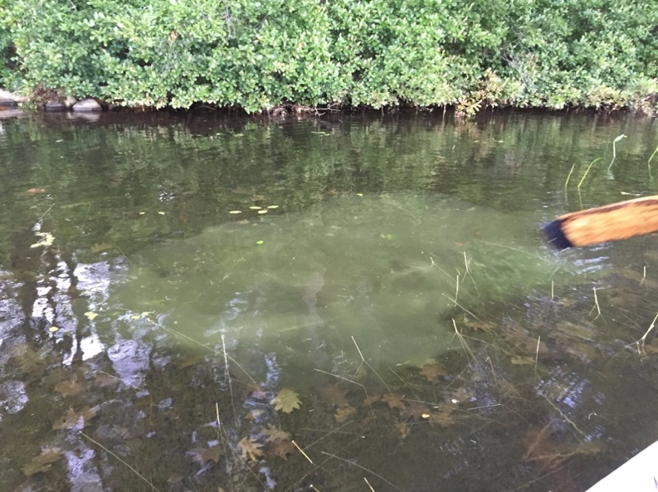season. That said, we continue to closely follow metaphyton’s appearance every year and **we all still need to be diligent doing our part to minimize run-off that contributes to pollutants entering the lake.**

Please review the 2022 lake survey/watershed report taken this year. Attention to the survey is needed to keep Wilson Lake pristine. In other news, I also have been recertified as a water quality monitoring another year on August 30th through Lake Stewards of Maine reporting to the Maine DEP. **~Rich Chevalier**

**Wilson Lake’s Water Level**

The WLA’s mission is to protect the water quality of Wilson Lake. With our mission in mind, we have been working over the past several years to maintain consistent water levels while minimizing shoreline erosion.

To this effect, WLA’s goal is to maintain a consistent lake water level during the recreational boating period from late May to mid-October. During these months we keep the lake artificially high with the use of the dam. This summer was quite dry as we all know, but the dam did well to hold the lake level at our “target” level. When heavy rain did arrive on the night of 8/22 we received 3.5 inches of water. The dam was open until the lake lowered to our “target” level. This took three and one half days, indicating that with the dam opened we can draw the lake down 1 inch per day when the rain has stopped.

The dam was opened fully in mid-October to prepare for the winter ice and to allow fish movement. It will be closed in 2023 sometime prior to Memorial Day depending upon springtime precipitation amounts. **~John Nadeau**

***Loons***

We have generally had two loons on the lake this spring during mating season when the loons are quite territorial, but no nesting activity occurred of which we are aware. If you know of a loon nest attempt this year, please call John Nadeau at 781-504-3143. He and Ann Marie are the Maine Audubon Loon Counters on Loon Day in July when all the loons in Maine are counted at the same time, rain or shine. Part of the count includes the location of any active nesting sites.

As it turned out only one loon was on Wilson Lake from 7:00 to 7:30 am during the Maine Audubon Annual Loon Count. Maybe one went fishing on Great East… Several more loons arrived later in July because loons raising chicks on other lakes continue to be territorial. Loons like Wilson Lake’s clean water, great fishing, and courteous boaters. The Loon Count has taken place for over 35 years and indicates that the loon population is stable. Thank you for not chasing them with motorized watercraft and keeping your distance when paddling. ~John Nadeau

**In memory of…**

ToAnne Daigle, who passed away on July 29, 2021. She absolutely loved the A-frame in Hawk Rd that the Daigle family has had for 40 years.

*And to all those we’ve lost from the Wilson Lake community this past few years, thank you for the lake we inherited! In preserving Wilson, WLA works to preserve the memory of those who loved the lake before us.*

If you’d like to have a lost loved listed in one of our bi-annual newsletters, please email us at [Wilsonlakeas@gmail.com](mailto:Wilsonlakeas@gmail.com)

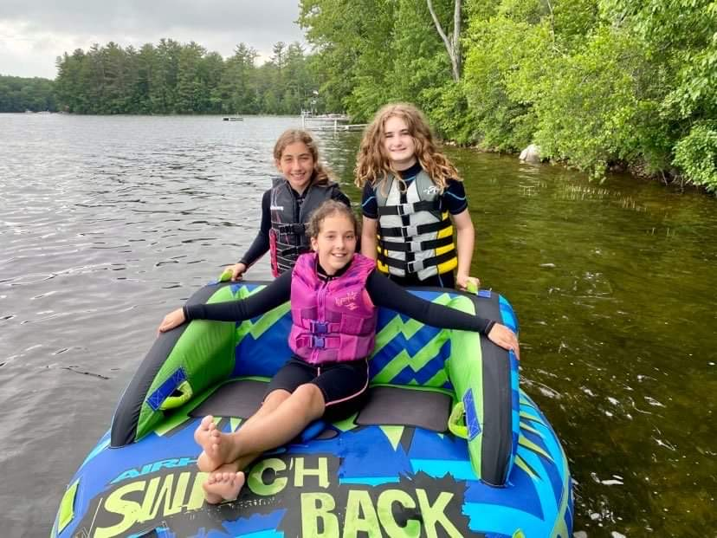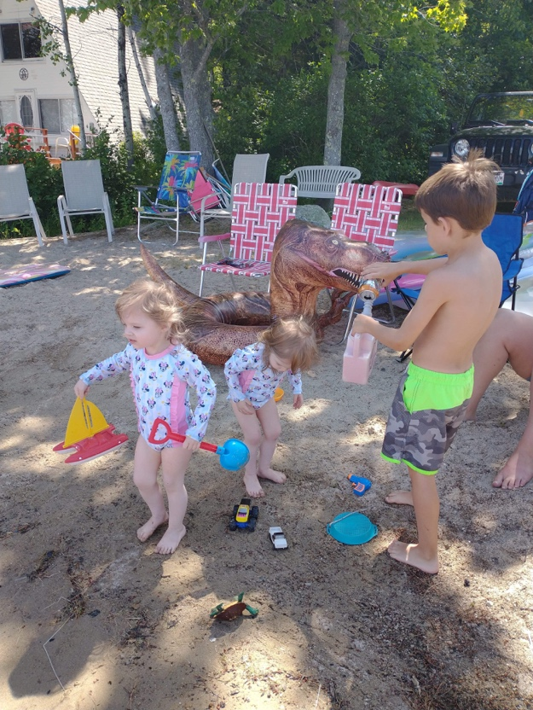**2022 “Summah” Season in Review—thanks to all who shared pictures on FB!**

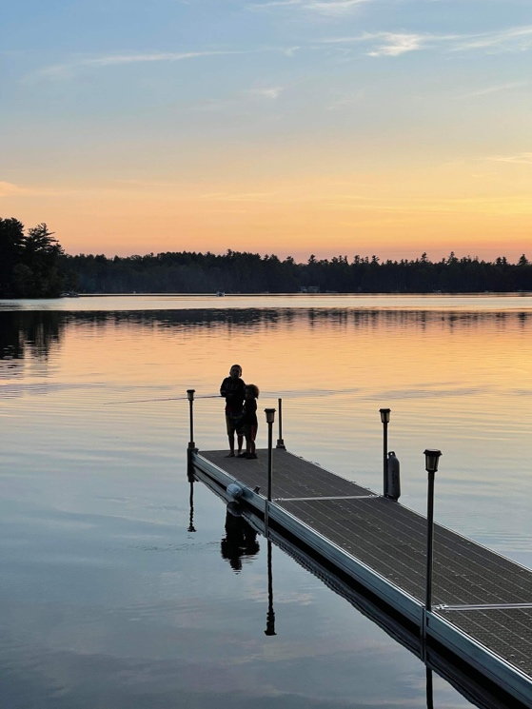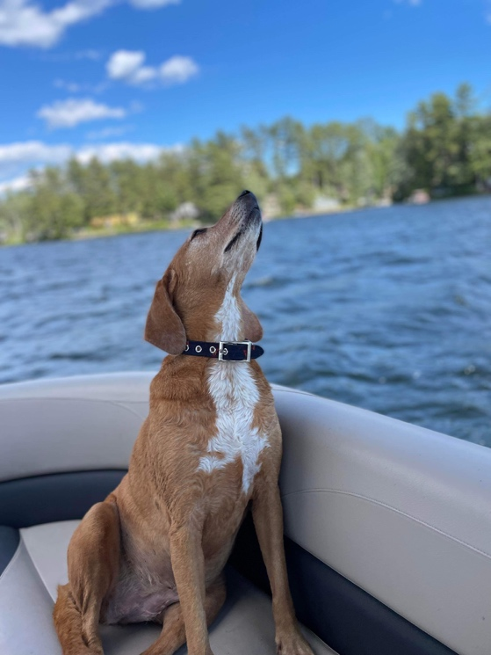

**Wilson Lake Gear is here!**

Check out our website or FB to click on links and getting your WLA gear today!

**Classic Design**

[**https://www.bonfire.com/wilson-lake-classic-design/**](https://www.bonfire.com/wilson-lake-classic-design/)

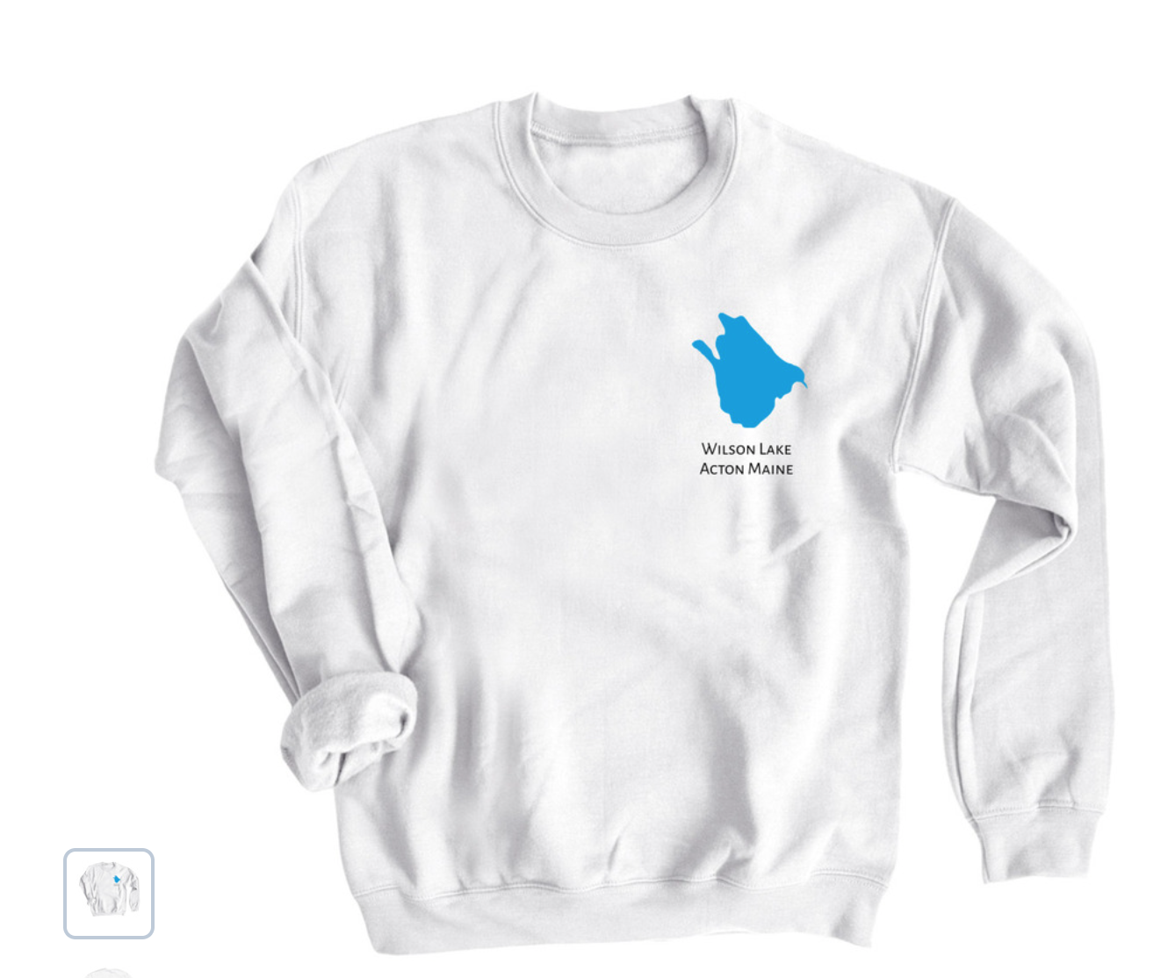

**“Sunset” Logo**

[**https://www.bonfire.com/wilson-lake-sun-and-water/**](https://www.bonfire.com/wilson-lake-sun-and-water/)

