**WILSON LAKE NEWLETTER**

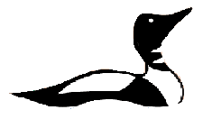

**SPRING 2019**

*“It is our collective and individual responsibility … to preserve and tend to the world in which we all live.”*

**—Dalai Lama**

Wilson Lake Web Site: <http://wilsonlake.net/>

Facebook: *Wilson Lake Association*

Email: [Wilsonlakeas@gmail.com](mailto:Wilsonlakeas@gmail.com)

**WLA President’s Message**  
June 219

We are sometimes asked, “What does the Wilson Lake Association do?” Other than ask you for $20 each year, here is a very brief review of what is happening.

Every two weeks from May to September Rich Chevalier goes out in his boat to test the water for clarity and dissolved oxygen. He also tests for phosphorus and e-coli twice a year. He submits these reports to the Lake Stewards of Maine who collect data for all the lakes in this program. Rich needs to be certified each year to do this testing.

Also, the University of New Hampshire has tested our lake water every other week for the last two years voluntarily guided by Susan Chadbourne. UNH is interested in Wilson Lake because it is a headwater for the Salmon Falls River which borders New Hampshire and Maine.

Sharyn and Wayne Reetz attend educational seminars to learn about invasive plants. Sharyn passed the Advanced Certification Plant Identification Test given by Lake Stewards of maine – No easy accomplishment! We are very fortunate to have immediate expertise and guidance if, and when a new invasive species is found (by one of you) in the lake.

Eric Cook has reviewed our most recent survey of the entire Wilson Lake watershed and knows which trouble spots we must monitor for polluting runoff erosion, which is mostly associated with our roads.

Lisa Flayhan has been acting as our Secretary. She also takes care of the Wilson Lake Association website wilsonlake.net She has done some research for us regarding the potential harm of introducing of foreign substances in the lake.

Jeff Brown is our Vice President. Along with his wife Rachel they produce the newsletter, prepare welcome packets with lake information for new owners, and are providing for some educational and social activities for us all who love Wilson Lake to both learn more and to know one another a bit better.

Isobel Michaud is busy improving our methods of communication by setting up and maintaining a Facebook page. If you are on Facebook please like us on Facebook.

Ann Marie Nadeau is our Treasurer and she keeps track of your dues payments, does our banking, taxes and pays the bills.

Several of us will be maintaining the dam to keep water levels stable through the summer months. Heidi and Arlie McGaw live near the dam and will help us with this task.

WLA communicates with Inland Fisheries and Wildlife regarding our fish population.

Bob and Kerry Garrity are working on providing fun and educational social events for kids who want to meet others and learn about our lake.

And we have of the Board, Dan Orino and Teg Rood, who have been involved with Wilson Lake for enough years that we can politely refer to them as our “Historians.” Not only do they have information about past events concerning the lake, but they contribute perspective regarding how well we are doing to protect this resource that we share.

I am fortunate to preside over a great group of talented and dedicated people who volunteer many, many hours of their time with one mission in mind. In the many years I have been at Wilson Lake (since 1973 if you must know) I have never heard anyone say that they wish the lake were more polluted. Now, in the past we have all had some ideas as to what does and what does not harm the lake water quality. But these days we have much more research on lakes – good scientific information about what keeps them clean and what causes them to become polluted. We now have a much better idea of what to do and what not to do. The Board’s job is to learn, and then share that knowledge with you.

At our May fourth Board meeting we adopted a new and simple Mission Statement that we all can remember. It answers the question I originally presented above. **The Mission of the Wilson Lake Association is to maintain and improve the water quality of Wilson Lake.**

How will we do that? Here is our Vision Statement that we also adopted. **The Wilson Lake Association will establish and maintain a program to reverse any trend of degrading water quality in Wilson Lake and to strive for continuous improvement in water quality. The Association will also encourage all Wilson Lake stakeholders to become educated regarding lake stewardship and to support cooperative efforts aimed at reducing or eliminating the impact of contaminants on lake water quality.**

By paying your dues, you are the Wilson Lake Association. And merely by reading further you will learn how you can help in small, but important ways, to keep Wilson Lake one of Maine’s best and cleanest bodies of water.

John Nadeau

**Upcoming Events –**

Saturday June 29 - Annual Meeting 9:00 AM at the Acton Fire and Safety Building.

Thursday July 4 - Boat Parade 10:00 meet in the outlet cove

Saturday July 6 – Fun and informative Nature Paddle with Mass Audubon Naturalist Martha in the outlet cove (rain date Sunday)

Saturday July 13 – Kid oriented Pancake Breakfast

***Membership in WLA***

Send your dues ($20) to Wilson Lake Association, PO Box 162. Acton, Maine 04001 ***or*** pay on website through PayPal or credit card.

Additional donations are welcome!

**Facebook Update:**

Our Facebook page has been up and running now for eight months. We are currently adding an event calendar, so liking the page will give you updates on all the exciting things happening on Wilson Lake.

Find us on Facebook by searching for “Wilson Lake Association”

So if you have a Facebook, *like* our page! The benefits include…

1. Updates on ways to help protect the lake we all love. These include fun videos, pictures, and updates on community events occurring on Wilson Lake
2. The ability to post a photo of our beautiful lake with the tag @WilsonLakeAssociation
3. Easy access to our amazing website, where you can contact the WLA board directly, read about upcoming events, etc.

Like us, tag us in your lake pics, and have fun!

Isobel Michaud

**Family Nature Paddle on Wilson Lake with Martha Gach, PhD**

Saturday, July 6th9:00-10:30

Meet at the boat launch 8:45AM

Arrive on your canoes, kayaks, paddleboards, paddleboats, floating anything with oars…

Join us on a leisurely tour with a Mass Audubon naturalist exploring the birds, plants, bugs and aquatic life on the shore of Wilson Lake.

This is a chance to discover the nature on our cherished lake and learn about what lives in and around the shore. Kids are welcome

(Rain date Sunday, July 7th9-10:30)

**Invasive Plant Report**

Until now, Wilson Lake has been free of invasive plants. Only our collective vigilance and good luck can keep it this way. The threat of invasive plants entering our lake is very real. Rapid identification of a new invasive plant could make all the difference

Two organizations, Lake Stewards of Maine (LSM) and the York County Invasive Aquatic Species Project (YCIASP), provide local workshops for aquatic plant identification. We have attended many of them over the last few years, and two that we hope you will consider attending are below.

A program sponsored by LSM and cohosted by WLA will be held June 28th from 10AM-4:00 PM in Alfred, Maine in the Alfred Chapel (building next to Alfred Parish Church on Kennebec Rd.). It will consist of a slide presentation followed by hands on identification of native and invasive water plants. Our past president, Jeanne Achille used to say that this class was fascinating; the time flies. Come for some informative fun. Pre registration is required. To register and see a description of the Invasive Plant Patrol 101 workshop (2nd one in the list), go to [https://www.lakestewardsofmaine.org/invasive-plant-patrol-workshops/](https://www.lakestewardsofmaine.org/invasive-plant-patrol-workshops/" \t "_blank). The program is free.

The second program is sponsored by WLA and will be held at the Wilson Lake boat ramp August 3rd from 9:30-12:15. Laurie Callahan from YCIASP will present an on-the-water, hands-on class that will be both fun and fascinating. Bring your kayak or canoe and come learn about the water plants that we have in our lake. Please arrive at 9:00 for set-up prior to starting at 9:30. Due to the hands-on nature of this class, there are only a limited number of spots (10-12) available, so go to our website [wilsonlakeas@gmail.com](mailto:wilsonlakeas@gmail.com" \t "_blank) to reserve yours.

We will be out on the lake this summer and hope to meet with some of you. Our goal is to be able to teach as many people as possible about plant identification in front of your own property and what to do if you find something suspicious.

Thank you for helping us keep Wilson Lake healthy.

Wayne and Sharyn Reetz

**Invasive Plant Patrol on Wilson Lake**

**Sign up soon. Limited to twelve people!**

**August 3rd,  9:00 AM until noon.  Outlet cove.**

An activity called Plant Paddles are free to those who wish to learn about what is growing in the lake.  They are led by an expert who will teach all of us what to look for, how to spot it and what to do about it. Paddles are casual, fun, interesting and a good way to meet our neighbors.  We have scheduled a Plant Paddle for August 3rd.  Only ten to twelve people can participate per Plant Paddle so reserve your spot early.  Email [wilsonlakeas@gmail.com](mailto:wilsonlakeas@gmail.com" \t "_blank)

**Golf balls/ Drive them at the range, save the Lake!**

We all love vacation! Swimming, boating, enjoying the cool lake waters with our friends and families! Golf is a fun activity that many enjoy as well, but I urge you not to combine the two! There are many lovely golf courses and driving ranges in the area to improve your swing and unload that stress, but hitting balls into the lake isn’t a good idea.

Year after year, golf balls are pulled out of our lake in various stages of disintegration.

Research teams at the Danish Golf Union have discovered that it takes between 100 to 1,000 years for a golf ball to decompose naturally. This unnatural material littering the bottom of our lake will remain in the sediment for generations into our future. If throwing empty beer and soda bottles off your dock is considered littering, hitting golf balls into the lake for kicks falls into the same category!

 While there isn’t a ton of research on the effects on fresh water from deterioration of golf balls, all indicators point to the conclusion that the toxins released are harmful to the lake and it’s inhabitants.

It has been shown that during decomposition, the golf balls dissolve to release a high quantity of heavy metals. Dangerous levels of zinc were found in the synthetic rubber filling used in solid core golf balls. When submerged in water, the zinc attached itself to the ground sediment and poisoned the surrounding flora and fauna. Other heavy metals used in golf ball production include tungsten, cobalt and lead; these can also leach into our lake.

Please consider these findings, and their effect on our lake and your property, before sending golf balls into our beautiful Wilson Lake. Thank you!

Lisa Flayhan

Below is a picture of a Golf Ball that corroded in a lake:

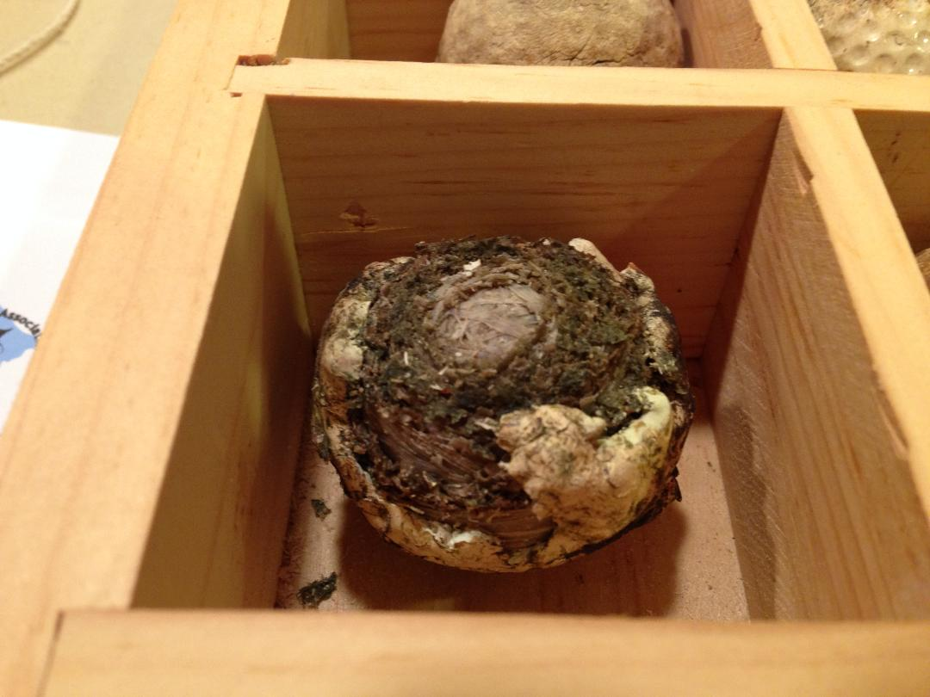

Photo below of an Algae Bloom on Province Lake, Wakefield NH caused by too much phosphate:

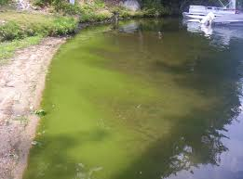

**Runoff; what can I do?**

Runoff is one of the two biggest threats to our lake; the other being invasive plants. What is runoff? Runoff is the water that flows across the watershed (all the land that surrounds the lake and “sheds” water into it) from snowmelt and rain and flows into the lake. With that runoff come all the pollutants that cause algae blooms, cyanobacteria blooms and other scary stuff.

As you see in the image below, the Wilson Lake watershed covers almost 4 square miles around the lake. All of the rain and snowmelt runs from that area into our lake. In undeveloped areas the water is filtered, slowed, trapped and cleaned by the forest and plants. In the developed areas, like our camps and roads, much of that filtering plant life is missing.

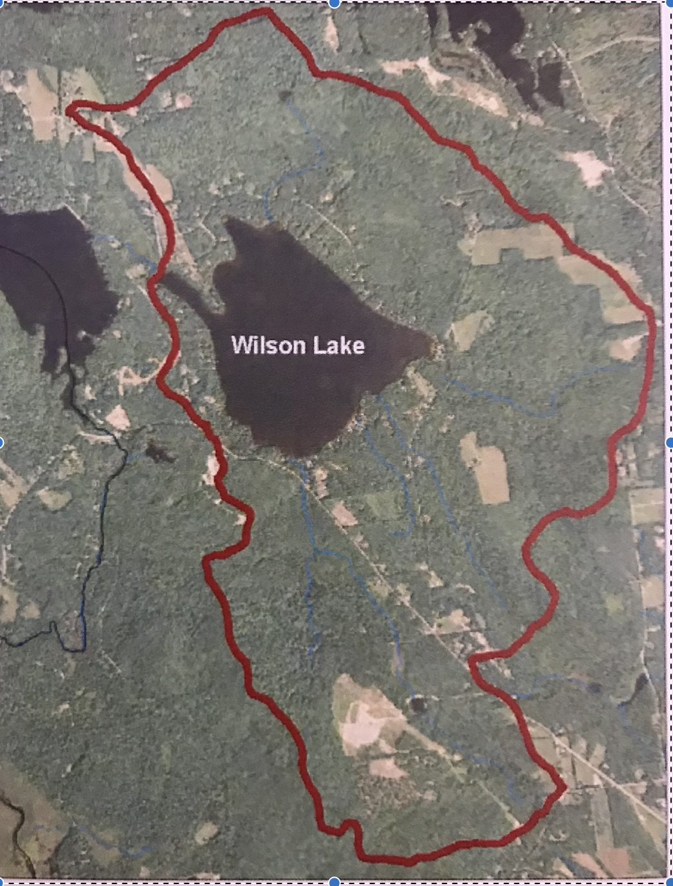

When the water has a free and open run to the lake, instead of being filtered, it becomes a highway for pollutants to enter our lake.

And the biggest pollutant we need to worry about is phosphorus.

Phosphorus occurs naturally in soil. It is also a component of fertilizers and sewage. If you fertilize your lawn or if your septic tank leaks; the phosphorus from those sources gets swept up as the water flows from a rainstorm and is deposited in the lake.

What can you do to help reduce the amount of phosphorus that flows into Wilson?

1. Have your septic tank serviced? Is it working properly? Are your sinks and toilets draining well, or are they slow or backing up? Do you smell sewer odors?

2. Reduce or eliminate fertilizing your lawns around the lake or use phosphate-free fertilizer

3. Fireworks contain phosphates. Consider reducing or relocating your fireworks so they don’t go into our lake

4. Take a look at your property. Is the flow of water unrestricted to the lake? If it is, there are a number of things you can do to slow the flow and filter it, ranging from simple mulch or crushed stone to more complex landscaping and plantings. AWWA Youth Corps can help you with these yard projects.

We all have an interest in keeping our lake crystal clean. We want to be able to swim in clean water and we want to maintain our property values.

Visit our website. You will find the 2010 Wilson Lake Watershed Survey Report as well as links to other resources.

And take a minute to join the WLA. Your membership dues will help our volunteer board help you to keep Wilson Lake the clean wonderful refuge from the outside world that we all cherish.

Eric Cook

**Far From The Tree -** Apples and Hard Cider

Al and Denise Snape started their hard cider business in September 2013 in Salem, Massachusetts. Far From The Tree began fermenting apples in January 2014 and released their first cider in mid-May 2014. Although they’ve only been in business a short time, the business has been brewing for years.

Over 10 years ago Al enrolled in the University of Brighton, Plumpton College Bachelor of Science program in Viticulture and Oenology in the UK. It has the distinction of being the only European winemaking degree program taught in English. Over the course of their time in England, they both became more interested in the process of making cider. Al had wanted to open a winery for years. “The idea of starting our own cider house was a bit of an epiphany during my dissertation, while studying and reading paper after paper about the difficulties of growing grapes in New England, and harsh climates in general. Time and time again the best solutions were always just to grow what worked best in that area without trying to force something to grow where it just isn’t meant to grow. Thus, the idea was born that we should make hard cider, not wine, in New England—its ingredients are what grow well here and as New Englanders that’s what makes the most sense to us. Don’t try to force it. Do what works, and do it well.”

Making hard cider, Denise notes, is a natural extension of the processes that Al learned while studying in England. Far From The Tree’s goal, she says, is to use these techniques to create a product of which the company can be proud. The company gets its apples October through April from orchards in central Massachusetts. The apples then go to a cider mill in Stow to be pressed. The same day, the fresh juice is brought to Far From The Tree’s Salem cellar, where it is pumped into oak barrels to begin the fermentation process.

Al and Denise took over a section of Romac Apple Orchard to grow apples for their hard cider. Al reports, “I am growing everything on the orchard organically.  I don’t use the usual pesticides and chemicals that some eating apple orchardists use.  Because I’m growing cider fruit, it doesn’t have to be as “perfect” as supermarket fruit, allowing me to run a much more environmentally friendly, less intensive program. The stream that feeds the lake on the east side is up over a hill from the bottom of my orchard, so my runoff does not make it to that stream from what I can tell.”

“My family and I live on the orchard part time during the winter and quite a bit during the summer.  We grow and eat vegetables from the soil and drink water and prepare formula for our son from the water from a well on the orchard.  Because of this, I’m especially careful about water quality.  I’ve tested our water and soil multiple times for every contaminant reasonable and have found no issues from previous use of the land and am extremely prudent concerning all things I do on the property that could have any affect on the land or water.”

**We are hoping to have an opportunity to sample Far From The Tree Cider at an End-of-Summer Wilson Lake social. Check our website for more information**